Good Morning Gator Nation!!!

Time is passing by very quickly. With two short weeks on either side of the Easter holiday, the fair will be here before we realize it. Please pay close attention to the calendar as many deadlines for items like ear tag orders, etc. are quickly approaching. Here are our updates for the week:

* **GCF&R Rule Revision**
* **April 5th Major Steer/Heifer Ear Tag Order Deadline**
* **GCF&R Work Day**
* **Fair Packets**
* **2024-25 Livestock Projects**
* **Steer Clinic**

**Activity Calendar**

**Show/Clinic Calendar**

**GCF&R Rule Revision**

Attached you will find amended General Livestock Rules and Junior Livestock Auction Rules.

The Auction Committee has implemented 2 rule changes for the upcoming 2024 fair:

* The Auction Picture will include the exhibitor and the Buyer "ONLY".

* There will be no Buyers' Gifts allowed on GCF&R premises.

* In the General Livestock Rules, the change is on #43 and on the Junior Auction Rules the change is on #9.

**April 5th Major Steer / Heifer Ear Tag Order Deadline**

Cattle Validation Tag ordering began **March 1, 2024**. The deadline for tag ordering will be **April 5, 2024**. Recognizing this is a very busy time for each of you, we wanted to make you aware of the ordering dates so you can begin contacting families in your county.

All state validated heifers will be tagged again, similar to steers. Please order tags accordingly. **COUNTY/CHAPTER WILL BE INVOICED AND CHARGED BASED ON NUMBER OF HEIFER TAGS ORDERED. This is the same for steers.**

Both steers and heifers will be charged at **$25 per validation fee.**Please keep in mind the validation fee is not only for the cost of the tag, but the entire validation system that includes personnel, travel to livestock shows, a robust online database/maintenance, and our validation compliance team that helps ensure our rules and guidelines are enforced to ensure a fair and level playing field for Texas livestock exhibitors.

There will certainly be much more communication to come. Please be on the lookout for updated guidelines and Ethics Policy in the coming months.

***Steer Validation:***

* Market Steer validation*fee ordering process online* at: [https://www.texaslivestockvalidation.com](https://urldefense.proofpoint.com/v2/url?u=https-3A__www.texaslivestockvalidation.com_&d=DwMF-g&c=r_tSStIHV2ie60z4DgB-pQ&r=g9YVexWMBt_xlrVcy6AOu17nqy03ICQqyf7zMgMpfCY&m=0ylKyrHHELqA63CspZf8SrXeovx-N99d1DZag81vqzQ&s=8pddqwdDaMLNYR6MCNy5hECpUuhq3znhUpYvUuxV_8g&e=)
  + Please *only* submit **ONE** order per county. This should be submitted by the County Validation Chairperson.
    - IMPORTANT NOTE: You will notice on the ordering screen that you are able to see selections for different species of livestock in which you may not be the chairperson (ie. market lambs, market goats and breeding heifers). Please ONLY submit an order for the species in which you serve as the validation chairperson. This could mean that you indicate a number for only one specie/division, or up to four species.
  + Your login information for [https://www.texaslivestockvalidation.com](https://urldefense.proofpoint.com/v2/url?u=https-3A__www.texaslivestockvalidation.com_&d=DwMF-g&c=r_tSStIHV2ie60z4DgB-pQ&r=g9YVexWMBt_xlrVcy6AOu17nqy03ICQqyf7zMgMpfCY&m=0ylKyrHHELqA63CspZf8SrXeovx-N99d1DZag81vqzQ&s=8pddqwdDaMLNYR6MCNy5hECpUuhq3znhUpYvUuxV_8g&e=) is the same as your HLSR access code and the code used for Heifer Validation. You may contact our office to retrieve this password. *These codes should only be used by CEA/ASTs. These are NOT to be distributed to parents.*
  + Once logged on, select “Manage My County/Chapter” and type the number of tags you need to order in the text box to the right of the species in which you serve.
  + See *attached* screen shots for submitting an online order.
  + NOTE: Once validated in June, steers are eligible through Fall and Spring major shows (2022-2023). There is only ONE steer validation per year.

* Validation fee for Steers
  + **$25** per head **March 1-April 5**
  + **$30** per head **April 6-June 23**
  + Payment will be due at the time of *invoicing*, not ordering. The website will generate email invoices that will be sent on April 26 for orders placed on or before the deadline. Late orders will be invoiced June 30. Please send payment with the invoice for each ordering period.
  + Steers will be charged a validation fee based on how many tags are ordered.
  + The Validation Chairperson that submitted the order will be the contact that is invoiced for the validation fee for the entire county.
  + **REMEMBER: you will not be able to order tags if there is an outstanding balance for your account.** That said, all invoices from previous seasons must be paid before you can order for this year. You may view/pay this balance by selecting Manage My County/Chapter and scrolling to the bottom of the page under the sections titled Validation Invoice History. If the status reads unpaid, these will need to be paid at this time.

***Heifer Validation:***

* Heifer validationfee ordering process will continue to be online at: [https://www.texaslivestockvalidation.com](https://urldefense.proofpoint.com/v2/url?u=https-3A__www.texaslivestockvalidation.com_&d=DwMF-g&c=r_tSStIHV2ie60z4DgB-pQ&r=g9YVexWMBt_xlrVcy6AOu17nqy03ICQqyf7zMgMpfCY&m=0ylKyrHHELqA63CspZf8SrXeovx-N99d1DZag81vqzQ&s=8pddqwdDaMLNYR6MCNy5hECpUuhq3znhUpYvUuxV_8g&e=)
  + **$25** per head **March 1-April 5**
  + **$30** per head **April 6-June 23**
  + Please *only* submit **ONE** order per county. This should be submitted by the County Validation Chairperson.
  + IMPORTANT NOTE: You will notice on the ordering screen that you are able to see selections for species in which you may not be the chairperson (ie. market lambs, market goats and market steers). Please ONLY submit an order for the species in which you serve as the validation chairperson. This could mean that you indicate a number for only one species, or up to four species.
  + Your login information for [https://www.texaslivestockvalidation.com](https://urldefense.proofpoint.com/v2/url?u=https-3A__www.texaslivestockvalidation.com_&d=DwMF-g&c=r_tSStIHV2ie60z4DgB-pQ&r=g9YVexWMBt_xlrVcy6AOu17nqy03ICQqyf7zMgMpfCY&m=0ylKyrHHELqA63CspZf8SrXeovx-N99d1DZag81vqzQ&s=8pddqwdDaMLNYR6MCNy5hECpUuhq3znhUpYvUuxV_8g&e=) is the same as your HLSR access code. You may contact our office to retrieve this password. *These codes should only be used by CEA/ASTs! These are NOT to be distributed to parents.*
  + Once logged on, select “Manage My County/Chapter” and type the number of UINs you need to order in the text box to the right of the species in which you serve.
  + NOTE: Once validated, heifers remain eligible through their show career unless they change breed or ownership. There is **no**need to re-validate a heifer if breed or ownership is not being changed.

* Validation fee for Heifers
  + **$25** per head **March 1-April 5**
  + **$30** per head **April 6-June 23**
  + Payment will be due at the time of *invoicing*, not ordering. The website will generate email invoices that will be sent on April 26 for orders placed on or before the deadline. Late orders will be invoiced June 30. Please send payment with the invoice for each ordering period.
  + Heifers will be charged a validation fee based on how many tags are ordered.
  + The Validation Chairperson that submitted the UIN order will be the contact that is invoiced for the validation fee for the entire county.
  + **REMEMBER: you will not be able to order tags if there is an outstanding balance for your account.** That said, all invoices from previous seasons must be paid before you can order for this year. You may view/pay this balance by selecting Manage My County/Chapter and scrolling to the bottom of the page under the sections titled Validation Invoice History. If the status reads unpaid, these will need to be paid at this time.

**GCF&R Work Day**

If you are available, please come out. This is a great opportunity for community service hours and a great way to represent Dickinson FFA! Lunch will be provided. If you have shovels, rakes, weedeaters, etc. you are asked to bring them.

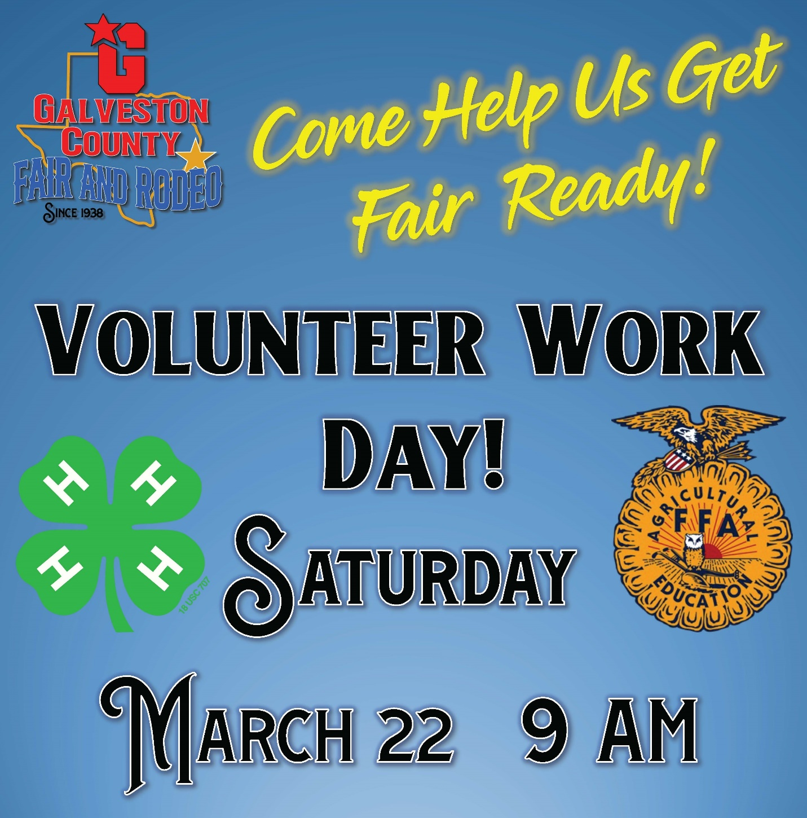

**Fair Packets**

After the conclusion of the chapter and the alumni meetings, we will be releasing all GCF&R wristbands and passes on April 3rd . With officer elections for both the students and the alumni taking place we need each respective party to attend its meeting first. Once both are completed we will reconvene in the Vintage Gym to distribute passes and discuss GCF&R plans.

**2024-2025 Livestock Projects**

This is the timeframe where a great deal of you want to start to plan getting animals for next school year. As we have done in years past, we first have to go through some paperwork updates and changes, as well do some housekeeping on our side. No new animals will be allowed into the facility until **after** Mandatory Barn Clean-Up, May 4th. We will be pushing out information in the coming weeks with the barn application, and all of the other administrative aspects that we have to take care of first.

**Steer Clinic**

We will have a steer clinic for those that can attend next Thursday, March 28th in the new barn show arena at 6 pm.

Let us know if you have any questions or concerns please let us know at your earliest convenience. Have a great weekend, and as always,

**GO GATORS!**

**Mitch Robinson**

**Ag Science Teacher / Barn Manager**

**Dickinson High School - Dickinson ISD**

P.O. Drawer Z

Dickinson, TX  77539

281-229-7858

NOTICE OF CONFIDENTIALITY:  This electronic transmission may contain CONFIDENTIAL INFORMATION belonging to the sender, which is legally privileged.  The information is intended for the sole use of the individual or entity listed above.  If you are not the intended recipient, you are hereby notified that any disclosure, copying, distribution, use, or taking any action on reliance of the contents of the information in this email is strictly prohibited and may violate DISD Board policy (Legal), the Family Educational Rights and Privacy Act (FERPA) and/or the Health Insurance Portability and Accountability Act (HIPAA).  If you have received this electronic message in error, please notify the sender immediately to arrange for the return and correction of internal records and delete the original message.