Good Morning Gator Nation!!!

Fair Week is finally upon us. Here are our updates for the week:

* **GCF& Teacher Schedule**
* **GCF&R Grounds Passes**
* **Reminder on Fair Rule Changes**
* **Barn Gate/Proxy Card Access**

**Activity Calendar**

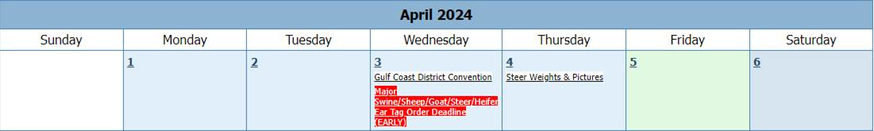

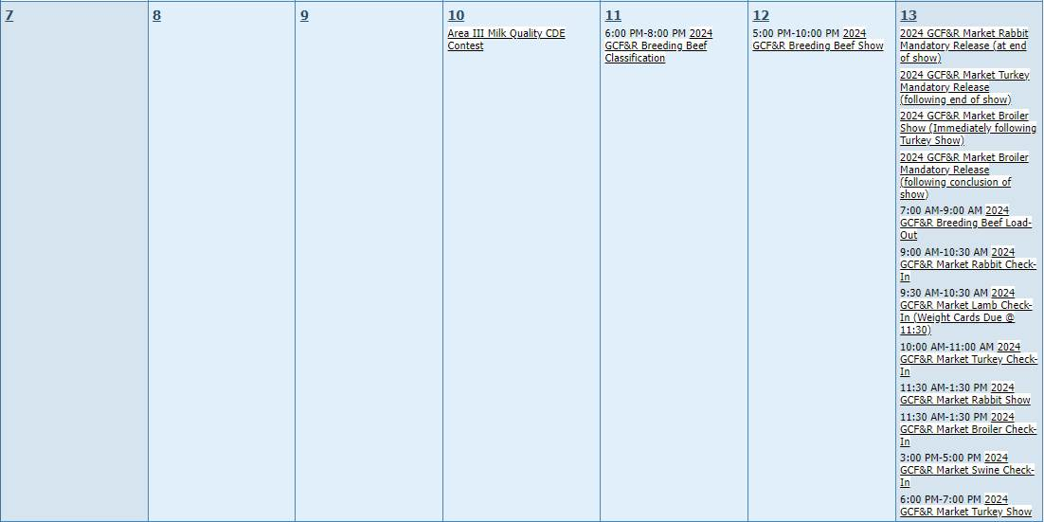

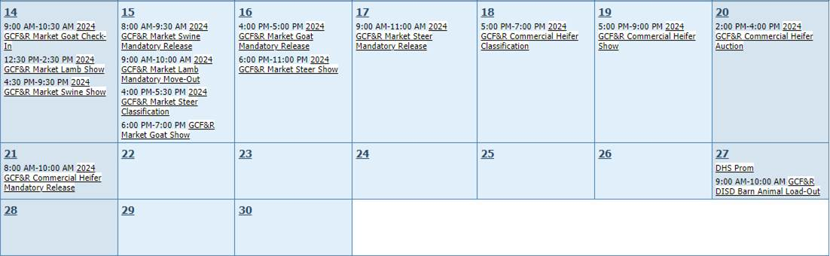

**GCF&R Teacher Schedule**

The following teacher will be at fair on the corresponding days. Please remember, students must check in with the Ag Teacher on duty by 8:30AM each day.

Friday 4/12

Lauren Murphy

Emily Hastings

Monday 4/15

Jordyn Cook

Alyson Sizemore

Alex Rocha

Kaylee Coppola

Tuesday 4/16

Kaylee Coppola

Lucas Edenfield

Wednesday 4/17

Lucas Edenfield

Alyson Sizemore

Thursday 4/18

Emily Hastings

Mitch Robinson

Friday 4/19

Mitch Robinson

Lauren Murphy

**GCF&R Grounds Passes**

Anyone that was not at the meeting Wednesday night, Mr. Menotti has your exhibitor packets. They need to get with me or their species advisor to pick it up.

**Reminder on Fair Rule Changes**

Please read the following closely and carefully:

***Galveston County Fair & Rodeo Information***

* *Please read through the exhibitor packet carefully for GCFR rules, there  have been some changes.*
* *The student is responsible for the daily care of their animal project(s) and stall(s) during the fair.*
* *Exhibitor Wristbands gain you entry to the fair each day. Students must wear THEIR wristband at all times. If a wristband breaks, it may be replaced at the livestock office one time, if it breaks again or it is lost, it will cost the exhibitor $5.*
* *Your Exhibitor Number must be worn during your show. If you lose your number, please go to the livestock office.*
* *If you need paperwork regarding commitments, auction/commitment add-ons, substitute exhibitor, stand-in exhibitor, proof of delivery, etc. please get with your species advisor or the livestock office.*
* *All students are excused from school the day of their show and the day after. However, it is up to the parents if their child comes to the fairgrounds or goes to school. Please notify an Ag Teacher if your student will be attending school. You still must arrange for your animal to be cared for. If a student is excused they must check in with an Ag Teacher on duty by 8:30 AM for attendance. If a student is excused and not present, the school will be notified of the truancy.*
* *On school days, there will be 2 or more Ag Teachers on duty at the fairgrounds during school hours (8:30a-2:30p) daily. Students are* ***NOT*** *allowed to leave the fairgrounds during school hours unless permitted by an Ag Teacher or with their parent/guardian.*
* *If a market animal exhibitor makes auction or their animal places high enough and their animal must stay on the grounds, that student will be excused for the rest of the week.*
* *If your livestock project makes the Jr Market Auction, you are required to attend the auction on April 17th.* ***NO BUYER GIFTS ALLOWED ON GCF&R PREMISES.*** *Pictures will be taken with the buyer and exhibitor only. Exhibitor, parent, guardian, shall NOT approach Buyer for special considerations. Exhibitors selling in the Auction are prohibited from making any substitutions of items sold.*
* *The student is responsible for getting to and from the fairgrounds daily. They must also bring their own food/drinks or money to purchase food from the vendors on site.*
* *Students will need to bring their own feed and supplies needed to care for their animal. It is suggested to keep items in a lockable showbox.*
* *Show boxes will be brought to the fairgrounds on Thursday, April 11th. If you would like for us to take your showbox, please have it in the middle drive of the barn with your last name and designated area marked on your box. You are responsible for picking up your box and any other personal items from the fairgrounds by Sunday April 21st.*
* *The FFA will purchase Tractor Supply Shavings for use while at the fairgrounds. These will be on site in our box trailer if you wish to use them.*
* *Students while there with their projects are representatives of Dickinson FFA and should dress and behave appropriately while on the fairgrounds. All DISD Student Code of Conduct rules apply.*
* *All animals returning to the barn still must be properly cared for until their departure date on or before Saturday April 27th.*
* *Non-Auction animals will return to the Ag Barn on the dates specified in the livestock schedule. You are responsible for seeking a buyer or commitment for your animal. All animals (except for second year breeding heifers) must leave the Ag Barn on or before April 27th.* ***NO EXCEPTIONS!***
* *Commitment animals will be hauled back to the fairgrounds at 7:00 AM on 4/27.*
* *Once animals have been removed from the barn on 4/27 students will be responsible for cleaning out pens, lockers, and storage areas and removing all personal items* ***BEFORE*** *the barn clean up on 5/4.*
* ***Mandatory Barn Clean Out!*** *Saturday May 4th 9:00 AM. Bring ALL barn keys with you. Only upon completion of a satisfactory barn clean up and returning your keys, your barn deposit will be returned to you. Barn deposits will only be returned on Barn Clean Up Day and can not be rolled over to next year. Failure to attend will result in forfeiture of barn deposit and risk of not being allowed in the barn next year. Excused absence from barn clean up consists of medical emergency with doctors note, or UIL event with note from coach/sponsor (48 hours in advance)*
* *If keys are not returned on or before 5/4, your deposit will be forfeited.*
* *Barn Keys will be reassigned for those requiring barn access after the barn clean up day (officers, breeding heifer exhibitors, etc.). If returning, new barn keys will be issued at the barn contract meeting*

**Barn Gate / Proxy Card Access**

With fair about to start and all sorts of movement, barn gate & proxy card access has now been changed to weekend hours from now through the end of fair.

Our gates were repaired yesterday afternoon and are back to fully functioning capabilities.

The time of the year that we have all been waiting for is finally here. Let one of us know if you need something. Let’s have a great and successful time at this year’s Galveston County Fair & Rodeo. Have a great weekend, and as always,

**GO GATORS!**



**Mitch Robinson**

**Ag Science Teacher / Barn Manager**

**Dickinson High School - Dickinson ISD**

P.O. Drawer Z

Dickinson, TX  77539

281-229-7858



NOTICE OF CONFIDENTIALITY:  This electronic transmission may contain CONFIDENTIAL INFORMATION belonging to the sender, which is legally privileged.  The information is intended for the sole use of the individual or entity listed above.  If you are not the intended recipient, you are hereby notified that any disclosure, copying, distribution, use, or taking any action on reliance of the contents of the information in this email is strictly prohibited and may violate DISD Board policy (Legal), the Family Educational Rights and Privacy Act (FERPA) and/or the Health Insurance Portability and Accountability Act (HIPAA).  If you have received this electronic message in error, please notify the sender immediately to arrange for the return and correction of internal records and delete the original message.